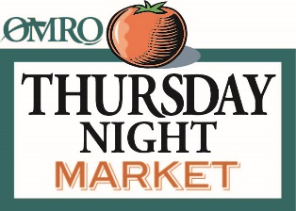
130 W. Larrabee Street; Omro WI
Shawkins@omro-wi.com 920-685-6960 x29
www.futureomro.org/thursday-night-market.html

January 04, 2021
Dear Omro Market Friend,
Thank you so much for your participation in Omro’s Thursday Night Market. As in past years, our main goal is to drive more people into the Market and increase sales for YOU. The hours will remain the same, 4–7 pm every
THURSDAY starting Thursday June 3, 2021 and ending on September 30, 2021.
Omro Thursday Night Market fee structure will remain the same: $50 per seasonal stall or $5 per weekly stall. The fees help to offset the cost of advertising, signage and labor needed to operate the Market. Seasonal participants will be assigned a numbered space. Just a reminder - we ask that you are checked in by 3:30. If you are going to be late, please let us know so we save your spot!
To assist in preparation for the Market, we’ve enclosed a copy of the Thursday Night Market Application, Market Policies, and the Wisconsin Temporary Event Operator and Seller Information form. You are responsible for obtaining any necessary permits and licenses required by Winnebago County or the
State of Wisconsin.
State of Wisconsin Department of Revenue-Temporary Events – (920) 832-2910 or (608) 266-2776
State of Wisconsin Weights and Measures Inspection – Robert Stobb – (920) 420-1149
Winnebago County Health Department – Anne Boyce – (920) 232-3000
Please be sure to carefully review all forms, signing and returning any areas that are highlighted, as many of these have changed.
We are truly excited about the future of the Omro Thursday Night Market and are sincerely pleased to be working with so many fine vendors in the area. As always, we welcome new vendors—so please pass along our information to any vendors you may know of who may be interested in participating in the Omro Thursday Night Market! Let’s make this another successful Market season!
Thank you and see you at the Market,
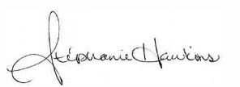
Stephanie Hawkins & Deb Wagner
Future Omro and Thursday Night Market Committee

