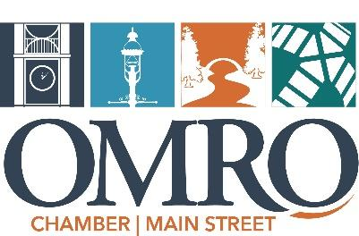

Partner Sponsorship Advertising & Volunteer Opportunities for 2023!

All sponsors will be recognized in print advertising and at the event itself. Please fill out the pledge form and return it to Future Omro (205 S Webster St. Omro, WI 54963) with sponsorship or volunteer time indicated. Please feel free to include payment with this form or an invoice will be sent approximately 30 days prior to the event(s) you have chosen to sponsor. Thank you for your support!

Business/Organization:
Names of volunteer(s):
Memorial Day- May 29
Advertising & Equipment | Volunteer Times
- $50 | - Car parking 6am-noon
- $100 | - Registration 6am-noon
- $150 | - Counting Ballots 11am
- $200 | - Food/Bev Sales- Several Shifts
- $250 | - Grill Crew: 7am-clean up
- Other:

Touch a Truck- May 29 (during car show) Advertising & Equipment
- $50 | - $100
- $150 | - $200
- $250 | - Other:

Omro Thursday Night Market- June- September
Advertising & Equipment
- $50 | - $100
- $150 | - $200
- $250 | - Other:

Fourth of July
Fireworks Sponsorship
- $250 | - $500
- $1000 | - $2000

Duck Sponsor
- $25 | - $25
- $50 | - $100
- $150 | - $200
- $500 | - $750
- $1000 | - $1500

Volunteer Times
- Parade Line up 10-1230  Various Shifts for: | - Duck Race 7pm-8pm
- Duck Ticket Sales 10-8 | - Food/Bev sales 10-9
- Grill Crew 10-9
Holiday Parade- December 2
Advertising, Candy, & Santa on Float
- $50 | - $100
- $150 | - $200
- $500 | - Other:

Holiday Party and Basket Raffle- December 6
Gift Basket Donations $50 Value Baskets

Contribution to be used wherever needed: Amount $

